**IT2120 – Probability and Statistics**

**Lab Sheet 8**

**IT24102891**

**Aththanayaka A.M.S.N**

1)

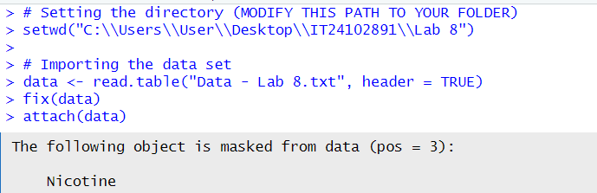

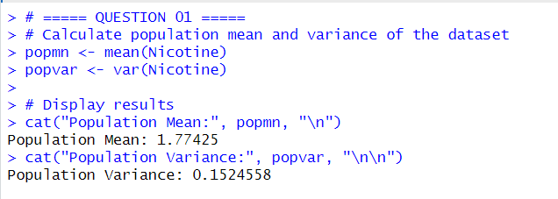

2)

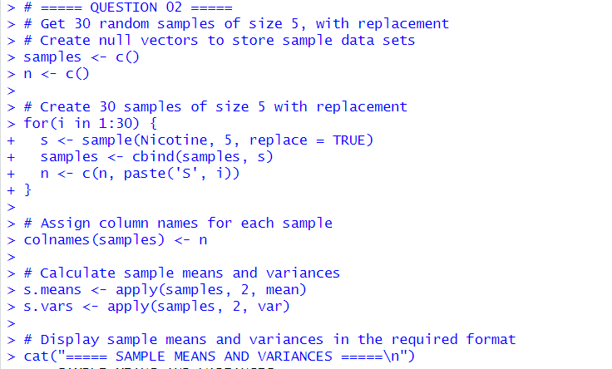

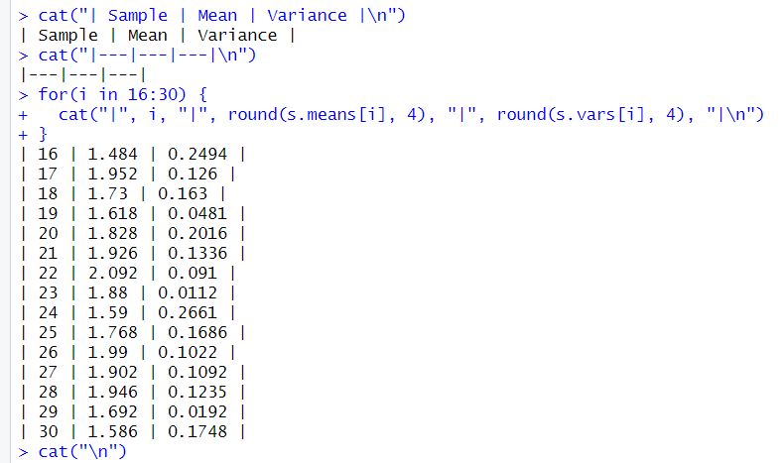

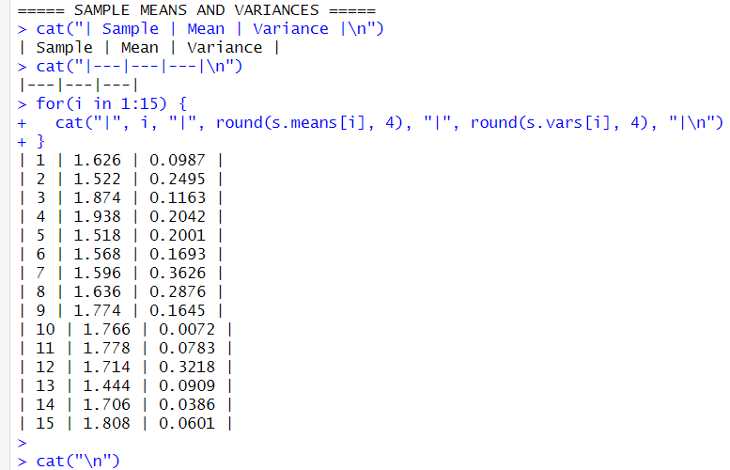

3)

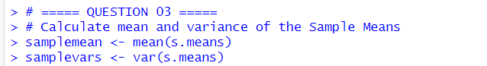

4)

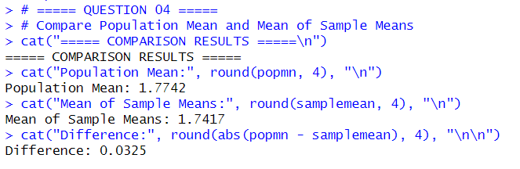

5)

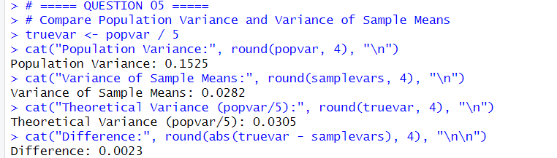

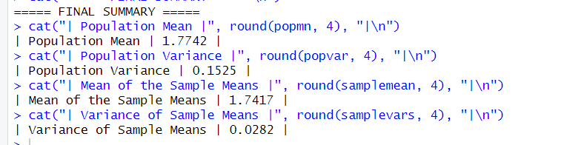

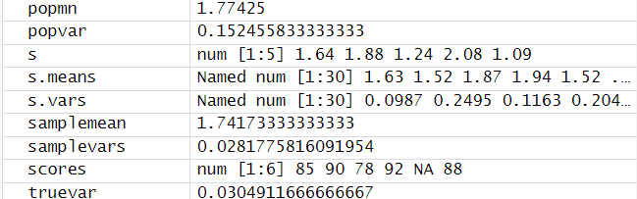

**Exercise:**



1)

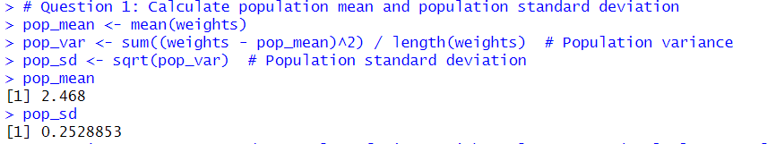

2)

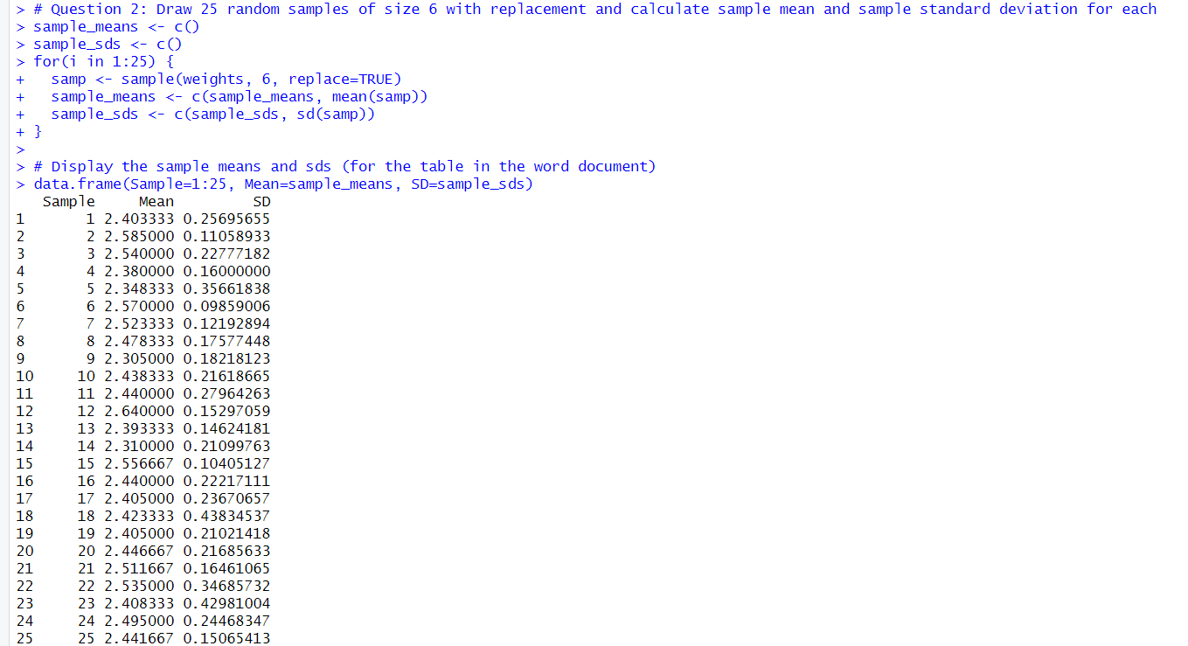

3)

